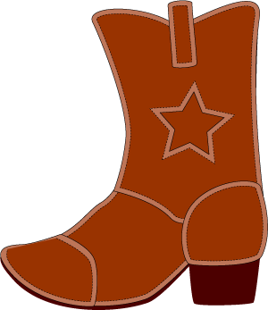Wild West Week

YELLOW SLIDE CIRCUIT
Climb up and slide down
Arabesque or Passe hold
Spiderwalk
Donkey kicks
Climb across ladder f or B Roll ***
Climb up
Straddle scoot
Ride the horse

PARENT/TOT CIRCUIT
Sideways bearcrawls
Walk on stones
Up the beam
Through the tunnel
Tabletop
Under tunnels
Spiderwalk
3x jumps
Lever touches

PARENT/TOT CIRCUIT
Bar-walk feet up wall
Up and down stairs
TaDa
Walk over stars
Forward roll UP mat
Cartwheel***
Hop down
Jump-together apart

TUMBLETRAK
Bird/Soldier/Rocket
Cartwheel***
Crawl under
Beam- jump over
TaDa on sheriff’s badge
Bar-Walk feet up wall
Spiderwalk
Tuck jumps

LOW BEAMS
Grasshoppers
Walk like a horse
Sideways-hands on hips like the Sheriff

BARS
N/A

RED SLIDE CIRCUIT
Arabesque on beam
Forward roll
Spiderwalk on bar
Lay on back and walk feet up red pole-pushing bottom off ground
Up the stairs
3 swings and drop
Bearcrawls
Backwards roll***
Up the stair
Down the slide
Rings-toes to the sky
Straddle scoot across horse

AGAINST THE WALL
Walk feet up the wall
Cartwheel***
Arabesque
Run BSR
Freeze
Jump up & down
Crawl across ladder
Monkey bars
Spiderwalk on red pole

YELLOW SLIDE CIRCUIT
Climb up and slide down
Arabesque or Passe hold
Spiderwalk
Donkey kicks
Climb across ladder f or B Roll ***
Climb up
Straddle scoot
Ride the horse

PARENT/TOT CIRCUIT
Sideways bearcrawls
Walk on stones
Up the beam
Through the tunnel
Tabletop
Under tunnels
Spiderwalk
3x jumps
Lever touches

PARENT/TOT CIRCUIT
Bar-walk feet up wall
Up and down stairs
TaDa
Walk over stars
Forward roll UP mat
Cartwheel***
Hop down
Jump-together apart

TUMBLETRAK
Bird/Soldier/Rocket
Cartwheel***
Crawl under
Beam- jump over
TaDa on sheriff’s badge
Bar-Walk feet up wall
Spiderwalk
Tuck jumps

LOW BEAMS
Grasshoppers
Walk like a horse
Sideways-hands on hips like the Sheriff

RED SLIDE CIRCUIT
Arabesque on beam
Forward roll
Spiderwalk on bar
Lay on back and walk feet up red pole-pushing bottom off ground
Up the stairs
3 swings and drop
Bearcrawls
Backwards roll***
Up the stair
Down the slide
Rings-toes to the sky
Straddle scoot across horse

AGAINST THE WALL
Walk feet up the wall
Cartwheel***
Arabesque
Run BSR
Freeze
Jump up & down
Crawl across ladder
Monkey bars
Spiderwalk on red pole

