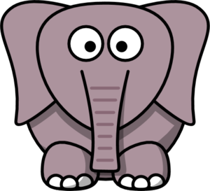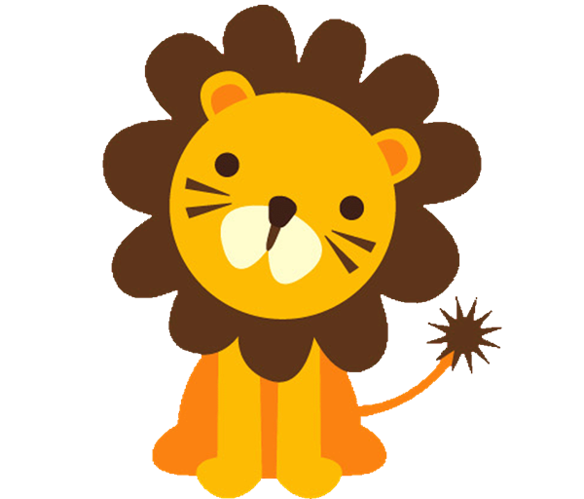Animal Week

YELLOW SLIDE CIRCUIT
Climb up the mountain
Slide down the river
Spiderwalk
Kangaroo Jumps 3x
Frog jumps in hoops
Tabletop
Climb like a monkey
‘Armadillo’ roll

PARENT/TOT CIRCUIT
Bar-pike with roses
Lever Touches
Spiderwalk
Jump
TaDa
Cartwheel***
Beam-swap ball b/t buckets
‘Armadillo’ roll

PARENT/TOT CIRCUIT
Donkey kicks
Climb through cave
‘armadillo’ roll
Go Fishing!
Cat Walk up beam
Jump TaDa
Climb up ladder
Superman/Mermaid Hold
Walk on stones

TUMBLE TRAK CIRCUIT
Pike roll-giraffe’s long les
Opossum hang- hands and feet around bar sideways
Bunny hops zigzag over beam
Frog jumps on mat
Spiderwalk
Starfish jumps (F & B))
OR Seat drops

SMALL BEAMS
Grasshoppers
Bearwalks
Cat walks
Releve-giraffe

Stick landing on red mat!

RED SLIDE CIRCUIT
Up the slide
Down the stairs
Rings-upside down like a bat
Flamingos on beam
Lion crawl up beams
Around the island
Down the stairs
Spiderwalk
Grasshoppers
Walk feet up pole
Climb up stairs
Hang/swing and drop
Flamingos on beam
Backwards armadillo roll***

AGAINST THE WALL
Monkey Bars
TaDa
Grasshoppers
TaDa
Front Support OR Pullover***
BSR
Tickles all the red spots
Through the cave
Forward pike roll
Through tunnels

YELLOW SLIDE CIRCUIT
Climb up the mountain
Slide down the river
Spiderwalk
Kangaroo Jumps 3x
Frog jumps in hoops
Tabletop
Climb like a monkey
‘Armadillo’ roll

PARENT/TOT CIRCUIT
Bar-pike with roses
Lever Touches
Spiderwalk
Jump
TaDa
Cartwheel***
Beam-swap ball b/t buckets
‘Armadillo’ roll

PARENT/TOT CIRCUIT
Donkey kicks
Climb through cave
‘armadillo’ roll
Go Fishing!
Cat Walk up beam
Jump TaDa
Climb up ladder
Superman/Mermaid Hold
Walk on stones

TUMBLE TRAK CIRCUIT
Pike roll-giraffe’s long les
Opossum hang- hands and feet around bar sideways
Bunny hops zigzag over beam
Frog jumps on mat
Spiderwalk
Starfish jumps (F & B))
OR Seat drops

SMALL BEAMS
Grasshoppers
Bearwalks
Cat walks
Releve-giraffe

Stick landing on red mat!

RED SLIDE CIRCUIT
Up the slide
Down the stairs
Rings-upside down like a bat
Flamingos on beam
Lion crawl up beams
Around the island
Down the stairs
Spiderwalk
Grasshoppers
Walk feet up pole
Climb up stairs
Hang/swing and drop
Flamingos on beam
Backwards armadillo roll***

AGAINST THE WALL
Monkey Bars
TaDa
Grasshoppers
TaDa
Front Support OR Pullover***
BSR
Tickles all the red spots
Through the cave
Forward pike roll
Through tunnels

