THIS WEEK’S SKILL FOCUS IS
CARTWHEELS
Did you know that the Cartwheel is one of the most basic skills in gymnastics but it is also one of the most important? Almost every event uses a cartwheel as both a building block skill and lead in skill. Not to mention, they are fun to do!
Today you may see:

- Lunges
- Lever Touches
- Kicking Drills
- Cartwheels over mats
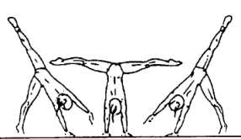
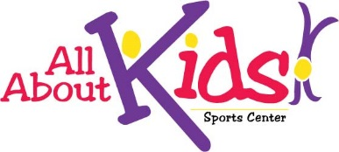
- Grasshoppers
- Straddles
- Drill Working Body Support

