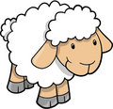 PIKES IN PAJAMAS WEEK

1-YELLOW SLIDE CIRCUIT
Climb up and slide down
Climb up and down the stairs
Walk over the stones
Bunny Hops
Walk up the beam
Lever Touches
Cartwheel***

2-OTHER PARENT/TOT CIRCUIT
Bar-walk feet up the wall
Climb the stairs
Trustfall or jump***
Balance Board
Releve
Climb the ladder
Forward roll
Passe hold
3 jumps
Releve through the cones

3- TINY CIRCUIT
Cartwheel***
Climb the ladder
Jump up onto block
Through the tunnel
Forward roll
Spiderwalk
Pike/vsit hold

4-TUMBLE TRAK
Straight Jumps
Pike Jumps
Seat Drops

5- SMALL BEAMS
Kicks
Bunny Hops
Sideways-I’m A Little Teapot
Releve
Humpty Dumpty tree falls-into pit

6- BEAMS
Releve or kick on beam
Stick dismount
Tuck or pike hold on PBars
Climb over mountain
Pike roll
Front support
BSR

7-BARS
N/A
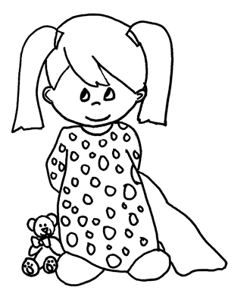

8-RED SLIDE CIRCUIT
Up the stairs-down the slide
Table Top walks
Swim across the pit
Jump side to side
Cartwheel***
Scooters-backwards-use only hands
Walk up the wall pullover
Crawl under tunnels

9-AGAINST THE WALL
Sideways Bearcrawls
Jump-hands down then pike on
Pike roll
Jump on beam
Sideways jumps
Walk feet up the bar
Jump into the tunnel
Walk down the beam
L/pike hold
Climb up and down rock wall

YELLOW SLIDE CIRCUIT
Climb up and slide down
Climb up and down the stairs
Walk over the stones
Bunny Hops
Walk up the beam
Lever Touches
Cartwheel***

OTHER PARENT/TOT CIRCUIT
Bar-walk feet up the wall
Climb the stairs
Trustfall or jump***
Balance Board
Releve
Climb the ladder
Forward roll
Passe hold
3 jumps
Releve through the cones

TINY CIRCUIT
Cartwheel***
Climb the ladder
Jump up onto block
Through the tunnel
Forward roll
Spiderwalk
Pike/vsit hold

TUMBLE TRAK
Straight Jumps
Pike Jumps
Seat Drops

SMALL BEAMS
Kicks
Bunny Hops
Sideways-I’m A Little Teapot
Releve
Humpty Dumpty tree falls-into pit

BEAMS
Releve or kick on beam
Stick dismount
Tuck or pike hold on PBars
Climb over mountain
Pike roll
Front support
BSR

RED SLIDE CIRCUIT
Up the stairs-down the slide
Table Top walks
Swim across the pit
Jump side to side
Cartwheel***
Scooters-backwards-use only hands
Walk up the wall pullover
Crawl under tunnels

AGAINST THE WALL
Sideways Bearcrawls
Jump-hands down then pike on
Pike roll
Jump on beam
Sideways jumps
Walk feet up the bar
Jump into the tunnel
Walk down the beam
L/pike hold
Climb up and down rock wall

